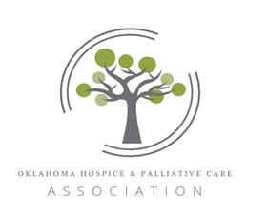
Oklahoma Hospice & Palliative Care Association
Sponsor/Vendor Prospectus
November 2 & 3, 2023

Who Can participate?
A sponsor/vendor is a business or organization providing education or services to hospice and palliative care programs.

Annual CONFERENCE GOALS
This conference is designed to assist health care professionals in understanding current issues in the delivery of Hospice and Palliative Care. Topics include pain/symptom management, conflict resolution, bereavement, communication, boundaries, spiritual care, patient’s rights, caregiver support and cultural diversity issues.

Target Audience
Hospital Nurses, Social Workers & Discharge Planners, Hospice Workers & Chaplains, Ethics Committees, Long Term Care Nurses, Medical Directors, and Administrators.

SPONSORSHIPS
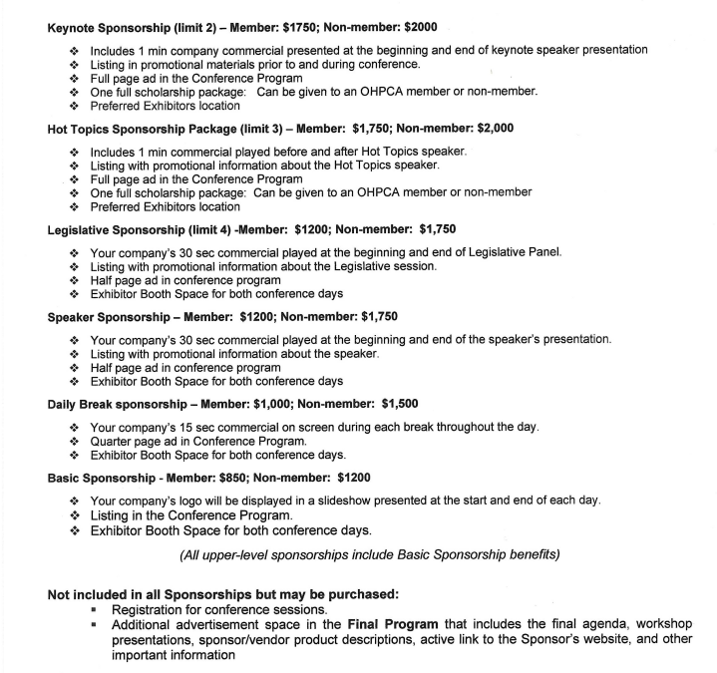

Non-Member Advertising rates are as follows:
- Inside Back Cover $500.00
- Outside Back Cover $550.00
- Inside Front Cover $500.00
- Double-Page Spread $500.00
- Full Page $400.00
- ½ Page $300.00
- ¼ Page $200.00

Patron Members receive a 10% discount
Be sure to apply early as Ad placement will be accepted on a first-come, first-serve basis.

SPONSOR CHECKLIST
- Application & Full Payment deadline – September 23, 2023
- COMMERCIAL/AD DEADLINE –October 1st, 2023
- Conference Theme – We appreciate vendors willing to coordinate with our conference theme, “Compassionate Hearts Moving Forward in Excellence”

Patron Membership
- Professional Membership is extended to organizations and institutions in the health care environment that support the hospice concept by providing goods and services that enhance the care of the terminally ill.
- The Oklahoma Hospice & Palliative Care Association (OHPCA) is the state-wide not-for-profit health care organization whose mission is to support and strengthen coordinated care for terminally ill patients and their families through the advancement of hospice care.
- OHPCA has provided educational and technical assistance to the growing number of hospice programs in the state, encouraging the growth and quality of service.
- Oklahoma hospices are linked in partnership with one another. Oklahoma hospices all have a goal of serving the needs of terminally ill patients and their families.
- Oklahoma hospices share resources and ideas as well as support and encourage one another.

WHY JOIN OHPCA

- To support quality care for the terminally ill and their families.
- Work with member hospice programs throughout the state of Oklahoma; and
- Support well-established educational events with excellent member participation.
- Discounts at all OHPCA sponsored events.
- Join our Facebook page.

- Join OHPCA committees.
- Have access to OHPCA Job Bank.

