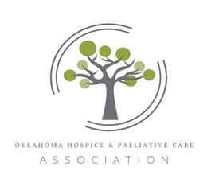

2023 Vendor Sponsorship Levels

Keynote Sponsorship (limit 2) – Member: $1750; Non-member: $2000
- Includes 1 min company commercial presented at the beginning and end of keynote speaker presentation
- Listing in promotional materials prior to and during conference.
- Full page ad in the Conference Program
- One full scholarship package: Can be given to an OHPCA member or non-member.
Hot Topics Sponsorship Package (limit 3) – Member: $1750; Non-member: $2,000
- Includes 1 min commercial played before and after Hot Topics speaker.
- Listing with promotional information about the Hot Topics speaker.
- Full page ad in the Conference Program
- One full scholarship package: Can be given to an OHPCA member or non-member
Legislative Sponsorship (limit 4) -Member: $1200; Non-member: $1,750
- Your company’s 30 sec commercial played at the beginning and end of Legislative Panel.
- Listing with promotional information about the Legislative session.
- Half page ad in conference program
Speaker Sponsorship – Member: $1200; Non-member: $1750
- Your company’s 30 sec commercial played at the beginning and end of the speaker’s presentation.
- Listing with promotional information about the speaker.
- Half page ad in conference program
Daily Break sponsorship – Member: $1000; Non-member: $1,500
- Your company’s 15 sec commercial on screen during each break throughout the day.
- Quarter page ad in Conference Program.
Basic Sponsorship - Member: $850; Non-member: $1200
- Your company’s logo will be displayed in a slideshow presented at the start and end of each day.
- Listing in the Conference Program.
(All upper-level sponsorships include Basic Sponsorship benefits)

Not included in all Sponsorships but may be purchased:
- Registration for conference sessions.
- Additional advertisement space in the Final Program that includes the final agenda, workshop presentations, sponsor/vendor product descriptions, active link to the Sponsor’s website, and other important information

