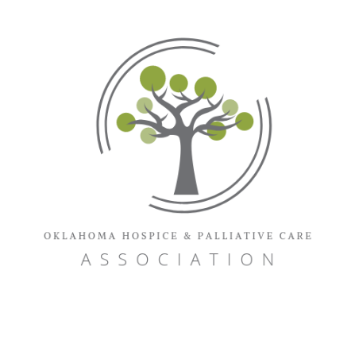
2023

Oklahoma Hospice & Palliative Care Association Annual Conference
November 2ne & 3rd

VENDOR/SPONSOR APPLICATION
Company:
Contact:
Address:
City/State/Zip:
Phone: |  |  | Fax:
Contact E-Mail:
Company Website:
Product
Description:
If using a company ad, describe
Listing in Final Program is different from above:

Company
Address:
City/State/Zip
Phone: |  | Fax:

Sponsorship/VENDOR APPLICATION
VENDOR/SPONSOR APPLICATION |  |  |  |  | pAGE 2
 |  |  | Member | Non-Member | Selection
Sponsorships | Keynote Sponsorship, (limit 2) |  | $1750 | $2000
 | Hot Topics Speaker Sponsorship (limit 3) |  | $1750 | $2000
 | Legislative Sponsorship, (limit 4) |  | $1200 | $1750
 | Speaker Sponsorship |  | $1200 | $1750
 | Daily Break Sponsorship |  | $1000 | $1500
 | Basic Sponsorship |  | $850 | $1200
Advertising Space in  Final Program |  | Inside Back Cover | $450 | $500
 |  | Outside Back Cover | $450 | $500
 |  | Inside Front Cover | $450 | $500
 |  | Full Page | $360 | $400
 |  | Half Page | $270 | $300
 |  | Quarter Page | $180 | $200

IMPORTANT NOTICE: Ad and commercial deadline is Oct 1st, 2023.

Contact OHPCA office with any questions; 1-405-985-9197
Vendor’s Conference Sessions Registration Fee |  |  | $225/person | $250/person

OHPCA Patron Membership - $700

(Join with application and receive 10% off your membership fee!!)

TOTAL DUE

Credit Card Payment
Credit Card  Number |  | Expiration Date
Name on Card |  |  | Code on Back of Card
Billing Address  for Card |  |  |  | Zip  Code
Signature

Send completed application to: Marta Sullivan, martasullivan64@gmail.com
Oklahoma Hospice & Palliative Care Association
PO Box 1466, Ardmore, OK 73402

If paying by check, make check out to OHPCA and send payment to address below

